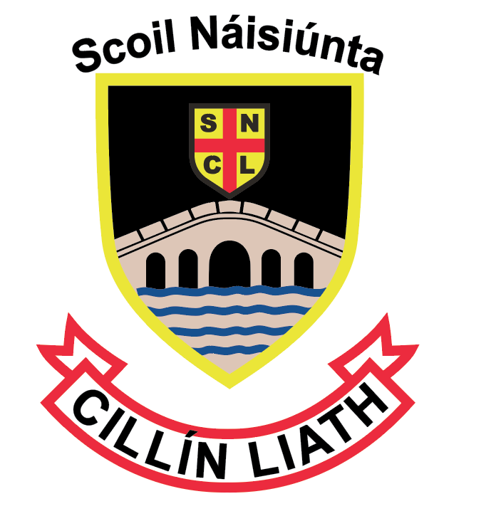
S.N. Cillín Liath, Maistir Gaoithe, Cill Áirne, Co. Chiarraí
Roll No. 19304B 066-9474474 / 087-0573017
Registered Charity No. 20123871
cillinliathns@gmail.com www.cillinliath.ie

Critical Incident Policy
S.N. Cillín Liath aims to protect the well-being of its students and staff by providing a safe and nurturing environment at all times. The Board of Management, through Elaine Joy, Principal, has drawn up a Critical Incident Management Plan as one element of the school’s policies and plans.
What is a ‘critical incident’
The staff and management of S.N. Cillín Liath recognise a critical incident to be “an incident or sequence of events that overwhelms the normal coping mechanism of the school”. Critical incidents may involve one or more students or staff members, or members of our local community. Types of incidents might include
- The death of a member of the school community through accident, violence, suicide or suspected suicide or other unexpected death
- An intrusion into the school
- An accident involving members of the school community
- An accident/tragedy in the wider community
- Serious damage to the school building through fire, flood, vandalism, etc
- The disappearance of a member of the school community
Aim
At S.N. Cillín Liath we recognise that the key of managing critical incidents is planning. Our hope is that in the event of a critical incident, this policy will help staff to react quickly and effectively maintain a sense of control and to ensure that appropriate support is offered to students and staff. Having a good plan should also help ensure that the effects on the students and staff will be limited. It should enable us to effect a return to normality as soon as possible.

Creation of a coping supportive and caring ethos in the school
We have put systems in place to help to build resilience in both staff and students, thus preparing them to cope with a range of life events. These include measures to address both the physical and psychological safety of the school community.
Physical safety
We have included the following practices into our Health and Safety Policy.
- Regular fire drills occur (termly)
- Fire exits and extinguishers are regularly checked
- Children cannot be taken from school during school hours without informing the principal.
- Pupils are regularly reminded of the rules of the playground. These rules are discussed and reviewed at staff meetings.
- Line up routine from yard
- Code of Behaviour Policy
- Health and Safety Policy

Psychological safety
The management and staff of S.N. Cillín Liath aim to use available programmes and resources to address the personal and social development of students, to enhance a sense of safety and security in the school and to provide opportunities for reflection and discussion.
- Social, Personal and Health Education (SPHE) is integrated into the work of the school. It is addressed in the curriculum by addressing issues such as grief and loss; communication skills; stress and anger management; resilience; conflict management; problem solving; help-seeking; bullying; decision making and prevention of alcohol and drug misuse. Promotion of mental health is an integral part of this provision
- Staff have access to training for their role in SPHE
- Staff are familiar with the Child Protection Guidelines and Procedures and details of how to proceed with suspicions or disclosures
- Books and resources on difficulties affecting the primary school student are available
- The school has developed links with a range of external agencies – the clergy, N.E.P.S., H.S.E, school nurse and cigire.
- The school has a clear policy on bullying and deals with bullying in accordance with this policy
- There is a care system in place in the school using the "Continuum of Support" approach which is outlined in the NEPS documents published on 2007 for primary schools and 2010 for post primary schools. These documents are available on www.education.ie

Critical Incident Management Team (CIMT)
A critical incident management team is a group of individuals from the staff who know the community, the students, and each other well enough to make the necessary decisions for when an incident occurs. The members of the teams were selected on a voluntary basis and will retain their roles for at least one school year. The members of the team will meet once a year to review and update the plan. Each member of the team has a dedicated critical incident folder. This contains a copy of the policy and plan and materials particular to their role, to be used in the event of an incident.
Roles
Key roles have been identified and assigned. The team includes:
Team Leader:
Staff Liaison:
Student Liaison:
Community Liaison:
Parent Liaison:
Media Liaison:
Administrative Tasks:
Health & Safety:

In the event of a critical incident the responsibilities of each role-holder will be as follows:
Team leader: (*Edit*name)
Role
- Alerts the team members to the crisis and convenes a meeting
- Coordinates the tasks of the team
- Liaises with the Board of Management; DES; NEPS; SEC
- Liaises with the bereaved family
Garda liaison (*Edit*name)
Role
(*Edit*May be seen as part of the team leader’s role)
- Liaises with the Gardaí
- Ensures that information about deaths or other developments is checked out for accuracy before being shared
Staff liaison (*Edit*name)
Role
- Leads briefing meetings for staff on the facts as known, gives staff members an opportunity to express their feelings and ask questions, outlines the routine for the day
- Advises staff on the procedures for identification of vulnerable students
- Provides materials for staff (from their critical incident folder)
- Keeps staff updated as the day progresses
- Is alert to vulnerable staff members and makes contact with them individually
- Advises them of the availability of the EAS and gives them the contact number.
Student liaison (*Edit*name)
A trusted and familiar person known to the students.
Role
- Alerts other staff to vulnerable students (appropriately)
- Provides materials for students (from their critical incident folder)
- Maintains student contact records (R1).
- Looks after setting up and supervision of ‘quiet’ room where agreed
Community/agency liaison (*Edit*name)
(Someone with good contacts with agencies and relevant individuals in the community).
Role
- Liaises with agencies in the community for support and onward referral.
- Updates team members on the involvement of external agencies. Co-ordinate the involvement of these agencies.
- Key parents such as members of the parent‟s council to be involved. Emergency support services and other external contacts and resources to be liaised with.
Parent liaison (*Edit*name)
(Someone who is well-known to parents. This person should be comfortable speaking before a large group and have skills to manage emotional reactions of individual or groups of parents.)

Role
- Visits the bereaved family with the team leader
- Arranges parent meetings, if held
- May facilitate such meetings, and manage ‘questions and answers’
- Ensures that sample letters are typed up, on the school’s system and ready for adaptation
- Sets up room for meetings with parents
- Maintains a record of parents seen
- Meets with individual parents
- Provides appropriate materials for parents (from their critical incident folder)
Media liaison (*Edit*name)
(Someone with good interpersonal skills who would be comfortable talking to the media, by phone, or in person. A person who is able to set limits without being offensive.)
Role
- In advance of an incident, will consider issues that may arise and how they might be responded to (e.g. students being interviewed, photographers on the premises, etc)
- Will draw up a press statement, give media briefings and interviews (as agreed by school management)
Administrator (*Edit*name)
Role
- Maintenance of up to date telephone numbers of
  - Parents or guardians
  - Teachers
  - Emergency services
- Takes telephone calls and notes those that need to be responded to
- Ensures that templates are on the schools system in advance and ready for adaptation
- Prepares and sends out letters, emails and texts
- Photocopies materials needed
- Maintains records
Record keeping (*Edit*name)
In the event of an incident each member of the team will keep records of phone calls made and received, letters sent and received, meetings held, persons met, interventions used, material used etc.
The school secretary will have a key role in receiving and logging telephone calls, sending letters, photocopying materials, etc.
Confidentiality and good name considerations
Management and staff of S.N. Cillín Liath have a responsibility to protect the privacy and good name of people involved in any incident and will be sensitive to the consequences of public statements. Members of school staff will bear this in mind, and seek to ensure that students do so also, e.g. the term ‘suicide’ will not be used unless there is solid information that death was due to suicide, and that the family involved consents to its use. The phrases ‘tragic death’ or ‘sudden death’ may be used instead. Similarly, the word ‘murder’ should not be used until it is legally established that a murder was committed. The term ‘violent death’ may be used instead.
Critical Incident Room:
In the event of a critical incident, the Staff room will be the main room used to meet the staff, students, parents and visitors involved. If a larger room is required the senior classroom will be used.
Consultation and communication regarding the plan
All staff were consulted and their views canvassed in the preparation of this policy and plan.
Parent/guardian representatives were also consulted and asked for their comments.
Our school's final policy and plan in relation to responding to critical incidents has been presented to all staff.
Each member of the critical incident team has a personal copy of the plan.
All new and temporary staff will be informed of the details of the plan by (Name of team member)
The plan will be updated annually in October.

Sínithe:
 | (Príomhoide) | (Cathaoirleach an Bhoird Bhainistíochta)
Dáta:
Dáta an chéad athbhreithnithe eile: |  | Deireadh Fómhair 2019

EMERGENCY CONTACT LIST
AGENCY | CONTACT NUMBERS
Garda
Hospital
Fire Brigade
Local GPs
HSE
Community Care Team
Child and Family Centre
Child and Family Mental Health Service (CAMHS)
School Inspector
NEPS Psychologist
DES
INTO/ASTI/TUI
Clergy
State Exams Commission
Employee Assistance Service | 1800 411 057

